Year 12 Chemistry Topic Test #5 - 2011

Name:__________________________________ Mark = _____ / 40

Part 1: Multiple Choice Section 10 marks
__________________________________________________________________________________

1. For the reaction:

5 I– + IO₃– + 6 H⁺  3 I₂ + 3 H₂O

which of the following statements is CORRECT?

A. The iodate ions act as the reducing agent.
B. The iodide ions act as the oxidisng agent.
C. The iodate ions are reduced.
D. The hydrogen ions are oxdised by the iodate ions.

2. When arsenious acid, H₃AsO₃, is oxidised to arsenic acid, H₃AsO₄, the number of moles of electrons supplied per mole of arsenious acid is:
A. 1
B. 2
C. 3
D. 4

3. For the reaction:

3 Au⁺(aq)  Au³⁺(aq) + 2 Au(s)

which of the following statements is TRUE?

A. Au⁺(aq) disproportionates
B. Au³⁺(aq) is a reducing agent
C. Au(s) is oxidised
D. A, B, or C are not true

4. Consider the following cell for which Eº values are:

X₂ + 2 e–  2 X– +0.54 V
Mg²⁺ + 2 e–  Mg –2.37 V
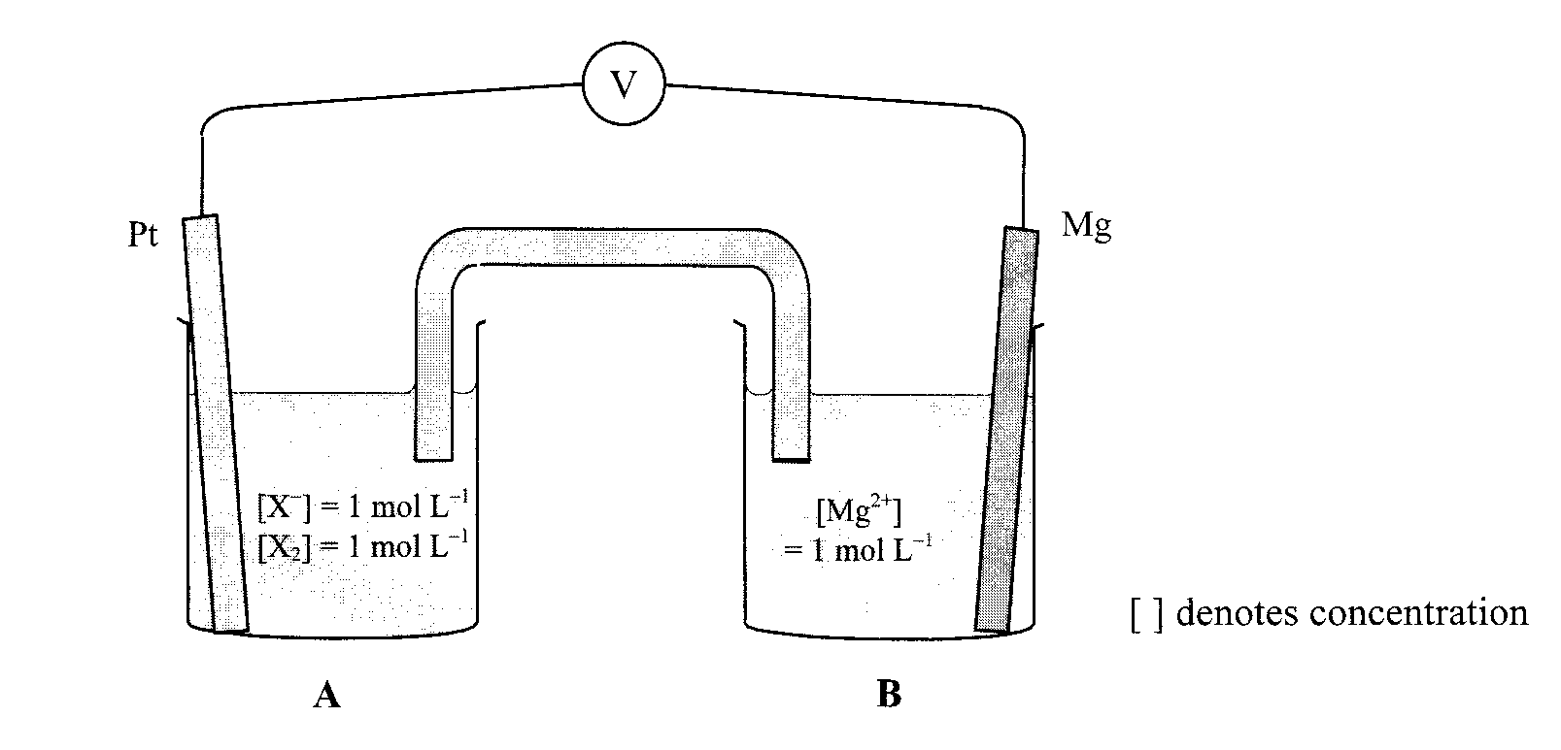

Which of the following statements is correct?

A. The voltmeter reading is 1.83 volt.
B. In half cell B, the reaction is Mg²⁺ + 2 e–  Mg.
C. The Mg electrode will become negatively charged with respect to the Pt electrode
and electrons will flow long the wire from Mg to the Pt.
D. If a piece of Mg is placed in 1.0 mol L^{–1} KX solution, X₂ is formed.

Questions 5 and 6 refer to the following reactions and their standard reduction potentials

Co³⁺(aq) + e–  Co²⁺(aq) + 1.30 V
Sn⁴⁺(aq) + 2 e–  Sn²⁺(aq) + 0.15 V
Sn²⁺(aq) + 2 e–  Sn(s) – 0.14 V
Cr³⁺(aq) + 3 e–  Cr(s) – 0.74 V
Be²⁺(aq) + 2 e–  Be(s) – 1.85 V

5. The strongest reducing agent is:

A. Sn²⁺
B. Be²⁺
C. Sn
D. Be

6. Which of the following would proceed substantially to the right?

A. 2 Co²⁺(aq) + Sn²⁺(aq)  2 Co³⁺(aq) + Sn(s)
B. Sn²⁺(aq) + Be²⁺(aq)  Sn⁴⁺(aq) + Be(s)
C. Be(s) + Sn²⁺(aq)  Be²⁺(aq) + Sn(s)
D. 2 Cr³⁺(aq) + 3 Sn²⁺(aq)  2 Cr(s) + 3 Sn⁴⁺(aq)
7. Potassium permanganate crystals would not be suitable for use as a primary standard in a
redox titration for which of the following reasons?

A. The end point for the titration is difficult to pick.
B. It needs heat to make the reaction proceed.
C. Its oxidising power makes its purity questionable.
D. It needs an acid present to control its reduction to Mn²⁺(aq).

8. In reacting metals A, B and C with solutions of A(NO₃)₂, B(NO₃)₂ and C(NO₃)₂, a student made
the following observations:

- metal A did not react with 1.0 mol L^{–1} B(NO₃)₂
- metal B dissolved in 1.0 mol L⁻¹ C(NO₃)₂ and crystals of C appeared
- metal C did not react with 1.0 mol L^{–1} A(NO₃)₂

The order of strength as a reducing agent is:

A. A > B > C
B. A > C > B
C. B > C > A
D. B > A > C

9. Which of the following cells would you expect to produce the highest EMF?
(Assume all electrolytes to be 1 mol L^{–1} aqueous solutions.)

A. Mg/Mg²⁺ // Zn²⁺/Zn
B. Mg/Mg²⁺ // Fe²⁺/Fe
C. Mg/Mg²⁺ // Ni²⁺/Ni
D. Mg/Mg²⁺ // Cu²⁺/Cu

10. Although aluminium is a strong reducing agent and is situated near the bottom of the table of
Standard Reduction Potentials, it does not corrode appreciably under normal conditions.

Which of the following best explains this?

A. Al forms a thin protective coating of oxide on its surface, preventing further corrosion.
B. It is alloyed with other metals to prevent corrosion.
C. The reaction between oxygen water and Al has a positive potential but the activation
energy for the reaction is too high for it to occur under normal conditions.
D. The reaction between Al and oxygen and water has a negative potential.

Part 2: Short Answer Section 30 marks
____________________________________________________________________________

Question 11 (5 marks)

Balance this unbalanced redox reaction; show all working. Complete the oxidation and reduction half equations and write the coefficients in the spaces provided.

____ MnO₄– + ____CO₂– + ____H⁺  _____MnO₂ + _____CO₄– + ____ H₂O

Oxidation _______________________________________________________________________

Reduction _______________________________________________________________________

Question 12 (6 marks)

Write a fully balanced, ionic equation and give an observation for any reaction that occurs in the following procedure. If no reaction occurs, write ‘no reaction’.

(a) Acidified hydrogen peroxide is added to potassium iodide solution.

Equation _____________________________________________________________________

Observation___________________________________________________________________

_____________________________________________________________________________
(3 marks)

(b) Concentrated nitric acid solution is added to zinc metal filings.

Equation _____________________________________________________________________

Observation___________________________________________________________________

_____________________________________________________________________________
(3 marks)

Question 13 (2 marks)

Give the oxidation number (state) of the underlined atoms in these examples:

(a) Cr(OH)₄– __________ (b) H₂S₂O₇ __________

Question 14 (9 marks)

Consider the electrochemical cell below:
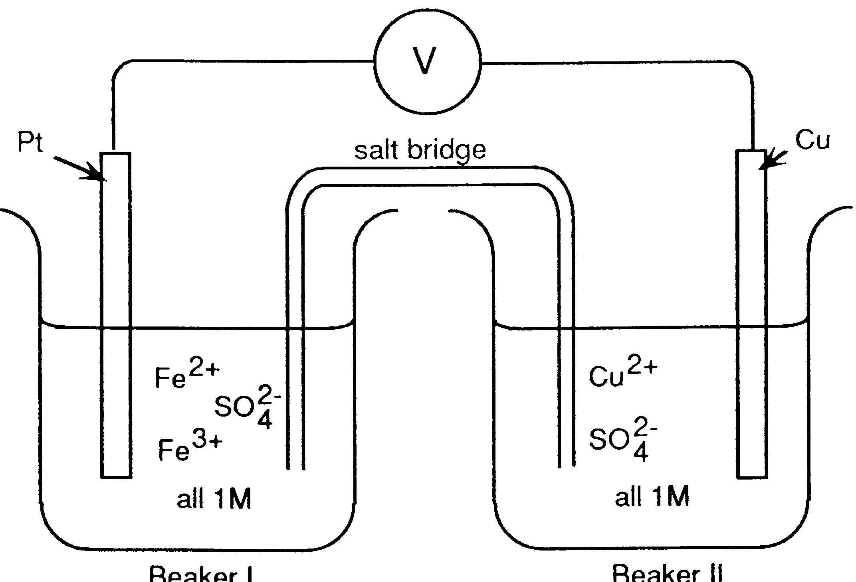
BEAKER I
BEAKER II

Fe³⁺ + e‾ Fe²⁺ E⁰ = 0.77 V
Cu²⁺ + 2e‾ Cu E⁰ = 0.34 V
Fe²⁺ + 2e‾ Fe E⁰ = -0.44 V

(a) (i) Determine the overall cell reaction.

_______________________________________________________________________
(1 mark)

(ii) Determine the EMF of the cell. ________________
(1 mark)

(b) The platinum electrode is now replaced by an iron electrode.

What happens to the direction of electron flow? Circle an alternative below.

Stays the same Stops flowing Reverses direction
(1 mark)
Explain your choice using appropriate equations.

_____________________________________________________________________________

_____________________________________________________________________________

_____________________________________________________________________________
(3 marks)

(c) 0.2 moles of electrons passes through the external circuit of the cell described in part (a).
What will be the change in mass of the anode?

_____________________________________________________________________________

_____________________________________________________________________________

_____________________________________________________________________________

_____________________________________________________________________________
(3 marks)
Question 15 (8 marks)

Dichromate ion (Cr₂O₇²⁻) may be used in a titration to analyse hydrogen peroxide solutions.

(a) Use your table of Standard Reduction Potentials to obtain the oxidation and reduction half equations and then write an overall equation for the reaction that occurs when potassium dichromate solution is added to a solution containing hydrogen peroxide and sulfuric acid.
Oxidation ____________________________________________________________________

Reduction ____________________________________________________________________

Full _________________________________________________________________________
(2 marks)

(b) Hairdressers use hydrogen peroxide to bleach hair. An analyst uses a pipette to transfer
20.00 mL of commercial hairdressers’ hydrogen peroxide to a 250.0 mL volumetric flask, and
she makes the volume up to the mark with distilled water. She places 20.00 mL portions of this
solution in a titration vessel, adds 5.00 mL of 2.00 mol L^{–1} sulfuric acid and titrates the mixture
with 0.02056 mol L^{–1} potassium dichromate. She records the following titration figures:

Final reading (mL) | 29.5 | 29.53 | 29.35 | 28.74 | 28.62
Initial reading (mL) | 0.11 | 1.55 | 0.41 | 0.81 | 0.66
Titre volume (mL)

Calculate the average titre.

_____________________________________________________________________________
(1 mark)

(c) Calculate the concentration, in mol L^{–1}, of the original commercial hairdressers’ hydrogen
peroxide.

_____________________________________________________________________________

_____________________________________________________________________________

_____________________________________________________________________________

_____________________________________________________________________________

_____________________________________________________________________________

_____________________________________________________________________________

_____________________________________________________________________________

_____________________________________________________________________________

_____________________________________________________________________________

_____________________________________________________________________________
(5 marks)
End of Test

SVACS

Year 12 Chemistry Topic Test #5 - 2011

Name: ANSWERS Mark = _____ / 40

Part 1: Multiple Choice Section 10 marks
__________________________________________________________________________________

1. C 2. B 3. A 4. C 5. D 6. C 7. C 8. D 9. D 10. A

Part 2: Short Answer Section 30 marks
____________________________________________________________________________

Question 11 (5 marks)

Balance this unbalanced redox reaction; show all working. Complete the oxidation and reduction half equations and write the coefficients in the spaces provided.

4 MnO₄– + 3 CO₂– + 4 H⁺  4 MnO₂ + 3 CO₄– + 2 H₂O ✓

Oxidation CO₂– + 2 H₂O  CO₄– + 4 H⁺ + 4 e– ✓✓

Reduction MnO₄– + 4 H⁺ + 3 e–  MnO₂ + 2 H₂O ✓✓

Question 12 (6 marks)

Write a fully balanced, ionic equation and give an observation for any reaction that occurs in the following procedure. If no reaction occurs, write ‘no reaction’.

(a) Acidified hydrogen peroxide is added to potassium iodide solution.

Equation H₂O₂(aq) + 2 H⁺(aq) + 2 I–(aq)  2 H₂O(l) + I₂(aq) ✓✓

Observation Two colourless solutions are mixed and the combined
solution turns brown (or a dark grey ppt forms if I2(s)) is used ✓
(3 marks)
(b) Concentrated nitric acid solution is added to zinc metal filings.

Equation Zn(s) + 4 H⁺(aq) + 2 NO₃–(aq)  Zn²⁺(aq) + 2 NO₂(g) + 2 H₂O(l) ✓✓

Observation A silver metal dissolves in a colourless solution producing a
brown pungent gas. ✓
(3 marks)

Question 13 (2 marks)

Give the oxidation number (state) of the underlined atoms in these examples:

(a) Cr(OH)₄– +3 ✓ (b) H₂S₂O₇ +6 ✓
Question 14 (9 marks)

Consider the electrochemical cell below:
BEAKER I
BEAKER II

Fe³⁺ + e‾ Fe²⁺ E⁰ = 0.77 V
Cu²⁺ + 2e‾ Cu E⁰ = 0.34 V
Fe²⁺ + 2e‾ Fe E⁰ = -0.44 V

(a) (i) Determine the overall cell reaction.

Cu(s) + 2 Fe³⁺(aq)  Cu²⁺(aq) + 2 Fe²⁺(aq) ✓
(1 mark)

(ii) Determine the EMF of the cell. 0.43 V ✓
(1 mark)

(b) The platinum electrode is now replaced by an iron electrode.

What happens to the direction of electron flow? Circle an alternative below.

Stays the same Stops flowing Reverses direction ✓
(1 mark)
Explain your choice using appropriate equations.

2 Fe³⁺(aq) + Fe(s)  3 Fe²⁺(aq) Eº = 1.21V ✓

This reaction has the highest Eº of the possible reactions and is therefore the
favoured reaction. No electrons flow through the circuit ✓✓
(3 marks)

(c) 0.2 moles of electrons passes through the external circuit of the cell described in part (a).
What will be the change in mass of the anode?

Cu(s)  Cu²⁺(aq) + 2 e–

n(Cu) = ½ n(e–) = 0.1 mole ✓

m(Cu) = 0.1 x 63.55 = 6.36 g (lost) ✓✓
(3 marks)

Question 15 (8 marks)

Dichromate ion (Cr₂O₇²⁻) may be used in a titration to analyse hydrogen peroxide solutions.

(a) Use your table of Standard Reduction Potentials to obtain the oxidation and reduction half equations and then write an overall equation for the reaction that occurs when potassium dichromate solution is added to a solution containing hydrogen peroxide and sulfuric acid.
Oxidation H₂O₂(l)  O₂(g) + 2 H⁺(aq) + 2 e⁻ (x 3) ½

Reduction Cr₂O₇^{2–}(aq) + 14 H⁺(aq) + 6 e–  2 Cr³⁺(aq) + 7 H₂O(l) ½

Full Cr₂O₇^{2–}(aq) + 8 H⁺(aq) + 3 H₂O₂(aq)  2 Cr³⁺(aq) + 7 H₂O(l) + 3 O₂(g) ✓

(2 marks)

(b) Hairdressers use hydrogen peroxide to bleach hair. An analyst uses a pipette to transfer
20.00 mL of commercial hairdressers’ hydrogen peroxide to a 250.0 mL volumetric flask, and
she makes the volume up to the mark with distilled water. She places 20.00 mL portions of this
solution in a titration vessel, adds 5.00 mL of 2.00 mol L^{–1} sulfuric acid and titrates the mixture
with 0.02056 mol L^{–1} potassium dichromate. She records the following titration figures:

Final reading (mL) | 29.5 | 29.53 | 29.35 | 28.74 | 28.62
Initial reading (mL) | 0.11 | 1.55 | 0.41 | 0.81 | 0.66
Titre volume (mL) | 29.39 | 27.98 | 28.94 | 27.93 | 27.96

Calculate the average titre.

Discarding readings 1 and 3, use average of other three readings.

(27.98 + 27.93 + 27.96) / 3 = 27.96 mL ✓
(1 mark)

(c) Calculate the concentration, in mol L^{–1}, of the original commercial hairdressers’ hydrogen
peroxide.

n(Cr₂O₇^{2–}) = c.V = 0.02056 x 0.02796 = 0.0005749 mol ✓

n(H₂O₂)_{20 mL dil} = 3 x n(Cr₂O₇^{2–}) = 0.001725 mol ✓

n(H₂O₂)_{250 mL dil} = 250 / 20 x n(H₂O₂)_{20 mLdil} = 0.02156 mol ✓

n(H₂O₂)_{20 mL conc} = n(H₂O₂)_{250 mL dil} = 0.02156 mol ✓

∴[ H₂O₂] = n/V = 0.02156 / 0.0200 = 1.078 = 1.08 mol L^{–1} ✓

(5 marks)
End of Test

